Tri-fold Mass Journal
If you have a 2-sided printer set the printer to print on both sides and flip on the SHORT edge. When it prints, it should be laid out as below.

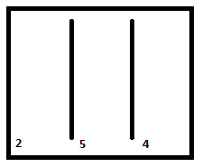
Side 1 Flipped on short edge, side 2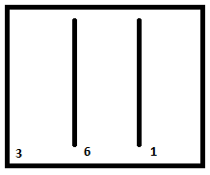

With side 2 facing up (showing pages 2, 5, and 4) fold page 4 over onto page 5. You should now see
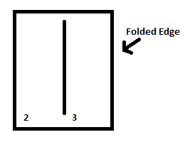

Finally, fold 2 over onto 3. Page 1 will be in front and your Mass journal is ready to go!

If you have a 1-sided printer, you can just print both pages and put them back to back as shown at the beginning of the instructions. Then fold as directed. The edges will end up slightly off, trim with scissors as desired.

